
Ref: UNDP/15/0/2025
Dear [Name of donor signatory in the cost sharing agreement],

Subject: Supporting Textile, Leather and Footwear Industries in Distressed Earthquake Provinces (STRIDE) Project Final Report

Reference is made to the contribution agreement between Government of Romania, Government of Sweden and UNDP for the project Supporting Textile, Leather and Footwear Industries in Distressed Earthquake Provinces is effective since 1 April 2024.

I am pleased to submit herewith the Final Report for the abovementioned project.

The report summarizes the progress of the project between 1 April 2024 and 30 September 2025 and provides an overview of the achievements, challenges, lessons learned, interim financial status and way forward.

I thank Government of Romania and Government of Sweden for its contributions to UNDP and look forward to strengthening our partnership in support of development in Türkiye in the future.

<Signature>
[Name of UNDP signatory in the agreement]
[Title of UNDP signatory in the agreement]
UNDP [country]

Attached:
Supporting Textile, Leather and Footwear Industries in Distressed Earthquake Provinces Project Final Report

[Name of donor signatory in the agreement]
[Title of the donor signatory in the agreement]
[Donor institution name]
[City, country]

Reporting Period | 1 April 2024 – 30 September 2025
Donor | Government of Sweden, Government of Romania
Country | Türkiye
Project Title | Supporting Textile, Leather and Footwear Industries in Distressed Earthquake Provinces Project
Project Locations | Kahramanmaraş, Hatay, Sanliurfa
Project ID  (QUANTUM Project ID)  Strategic Plan and/or CPD Outcomes | 01002273  Output 2.1: Capacities at national and local levels strengthened to promote inclusive local economic development.  Output 2.4: Disadvantaged groups, particularly the rural poor, women, and youth, gain access to financial and nonfinancial assets and skill formation to benefit from sustainable livelihoods and jobs.
Implementing Partner(s) | DOĞAKA, IHKİB Education Foundation , TARDE
Project Start Date | 1 April 2024
Project End Date | 30 September 2025
LPAC Date | -
Steering Committee/Project Board Meeting Dates | -
SDG linkages | TARGET_8.3- Promote development-oriented policies that support productive activities, decent job creation, entrepreneurship, creativity and innovation, and encourage the formalization and growth of micro-, small- and medium-sized enterprises, including through access to financial services
GEN marker | GEN 2
2025 Delivery to Budget Ratio | 100%
2024-2025 Work Plan Budget | USD 1,920,000
Total resources required
Revenue received | Donor  Gov. of Sweden USD 110.000,00  Gov. of Romania USD 300.000  Total USD 1, 920,000
Unfunded budget | USD
UNDP Contact Person | Cem Bayrak  Portfolio Manager  UNDP Türkiye  Email: cem.bayrak@undp.org  Tel.: +905413879928

Executive Summary

The “Supporting Textile, Leather and Footwear Industries in Distressed Earthquake Provinces (STRIDE) Project” was implemented between April 2024 and September 2025 in the earthquake-affected provinces of Kahramanmaraş, Şanlıurfa and Hatay. Project has been implemented to contribute to the socio-economic recovery of this provinces, which were among the areas most affected by the February 2023 earthquakes. The project aims to restore production capacity, improve business resilience, and promote sustainable employment opportunities in the leather/footwear, textile and apparel sectors through infrastructure support, skill development, and psychosocial assistance.
Building upon strong local partnerships and private-sector engagement, the project focuses on the establishment of common-use production facilities and the provision of advanced equipment to small and medium-sized enterprises (SMEs). These efforts aim to strengthen competitiveness, ensure business continuity, and prevent the loss of export and supply chains in the region’s key manufacturing sectors.
Additionally, the project supports human recovery by providing technical and vocational training, on-the-job learning opportunities, and job-matching services—particularly targeting NEET youth and women. Psychosocial support and mental health services are integrated to address post-disaster trauma and improve workplace well-being, productivity, and retention.
The project is jointly implemented by the United Nations Development Programme (UNDP) in Kahramanmaraş, Şanlıurfa and Hatay affected by earthquakes as a part of UNDP’s recovery response. For this aim, UNDP joined forces with three pioneer institutions to support businesses and individual needs in all aspects; Eastern Mediterranean Development Agency (DOĞAKA), the İHKİB Education Foundation, and the Disaster Mental Health Studies Association (TARDE) under Bilgi University. Through this partnership, UNDP leverages its implementation capacity and field presence; DOĞAKA mobilizes regional knowledge and resources; İHKİB Education Foundation provides sectoral expertise, training, and job placement; and TARDE ensures the establishment and operation of the Occupational Mental Health Center in Reyhanlı.
By combining infrastructure rehabilitation, business development, and psychosocial support, the project seeks to build resilience among affected businesses and workers, contributing to long-term economic recovery and social stability in Türkiye’s earthquake-hit provinces.
Overall, the implementation of the STRIDE Project also revealed several operational and contextual challenges in the post-disaster environment, including sectoral stagnation, logistical constraints, and coordination needs at the local level. At the same time, the project generated important lessons learned, particularly on the value of an integrated recovery approach that combines infrastructure support, business development, skills training, and psychosocial assistance. These experiences provide useful insights for strengthening the design and implementation of future post-disaster recovery initiatives.
The project aims to support the recovery and resilience of businesses and individuals in the leather/footwear and apparel sectors affected by earthquakes in Antakya/Hatay and Kahramanmaraş through the establishment of common-use facilities, and provision of sophisticated equipment. The project seeks to enhance production capacity and product quality for small businesses. Additionally, it aims to strengthen the business capacities of SMEs by providing business development support, including skill development training and networking opportunities. The project also focuses on empowering employment by offering technical vocational training and job matchmaking services, particularly targeting vulnerable populations like NEET youth and women. Finally, it aims to enhance resilience through mental health support services, including counseling and awareness-raising initiatives. By addressing both infrastructure and socio-economic needs, the project aims to contribute to the long-term recovery and sustainability of the earthquake-affected regions.
In this regard, in cooperation with DOĞAKA, a common-use footwear manufacturing facility was established in Hatay, while a common-use laser cutting facility serving the textile sector was set up in Kahramanmaraş. These centers were equipped with relevant machinery and equipment to enhance production capacity and product quality for small businesses.
Alongside, through collaboration with İHKİB, vocational training was provided to a total of 995 individuals, of whom 968 were NEET youth and 909 were women, with the aim of strengthening the business capacities of SMEs and improving employability. To further support market access and employment opportunities, three B2B matchmaking events were organized in Istanbul, creating linkages between producers and buyers. As a result of the training and matchmaking activities, 139 individuals from Şanlıurfa and Kahramanmaraş were successfully employed.
Additionally, in partnership with TARDE, an Occupational Mental Health Center was established in Reyhanlı, Hatay, providing individual psychological counselling, group sessions, and awareness-raising activities. By addressing both infrastructure-related needs and socio-economic and psychosocial challenges, the project contributes to the long-term recovery, resilience, and sustainability of earthquake-affected regions.

Background Information
The earthquakes in southern Türkiye on 6th and 7th February 2023 killed at least 50,700 people, destroyed more than 313,000 buildings, and left 3.3 million people homeless across 11 provinces with a territory of 110,000 sq. km. The earthquakes also had an unprecedented impact on the region’s economic life. According to TERRA, earthquakes destroyed 220,000 businesses (ILO) and formal employment dropped by 614,000 across the region. Especially the provinces of Kahramanmaraş and Hatay lost 68% and 58% of their insured wage earners respectively.
The earthquake-affected region holds a critical position in Türkiye’s economy, particularly in textile, carpet, and footwear production. It accounts for 61% of Türkiye’s carpet exports, 17% of its textile exports, and 35% of footwear production nationwide. Hatay’s Small Industrial Zone (SIZ), home to around 470 footwear producers, suffered severe damage, causing heavy losses of equipment and materials. Approximately 160 footwear producers relocated to the Organized Industrial Zone (OIZ) in Reyhanlı, where the Türkiye Exporters Assembly (TİM) provided over 300 containers for temporary operations.
The Eastern Mediterranean Development Agency (DOĞAKA) established a shared production atelier in the OIZ and supported the creation of new facilities, including a women’s shoe production site in Kahramanmaras and a textile facility in Elbistan. However, further investments in shared production spaces, equipment, technical and vocational training, and a skilled labor force remain urgent needs.
After the earthquakes, UNDP and Istanbul Readymade Garments Exporters Association Education Foundation (İHKİB Education Foundation) provided private-sector-driven technical and vocational trainings in Malatya, Şanlıurfa, and Adıyaman to 42 head-workers (Training of Trainers) and 20 NEET women. Employees.. Additionally, 1,844 employees and family members benefited from psychosocial and mental health support services, addressing issues such as trauma, anxiety, and family distress caused by the earthquakes. These challenges continue to affect labor productivity, highlighting the importance of integrating mental health into economic recovery efforts.
Despite national and international support, recovery across the region remains slow. Production capacity and employment in the textile and leather sectors are significantly reduced, and many SMEs risk losing their market positions due to infrastructure losses, equipment damage, and labor shortages.

Progress Review
Output 1: The physical capacity of businesses in the leather/footwear and apparel sectors will be supported through the establishment of common-use facilities.
Within the scope of Output I, a needs assessment study was conducted to assess the current situation of ready-made, textile, leather, footwear industries affected by the earthquake, especially in Kahramanmaraş, Şanlıurfa and Hatay. The assessment identified the major production challenges faced by local manufacturers, including the loss of machinery, workspace, and raw materials.
Based on the findings, the project supported the establishment of two common-use production facilities to restore and enhance industrial capacity in the region. In Antakya (Hatay), a shoe-upper production facility was set up to enable small footwear workshops to continue production using modern and shared machinery. In Kahramanmaraş, a laser cutting and pattern facility was established to support apparel SMEs, improving product quality, precision, and efficiency.
Activity 1: Establishment of one common-use shoe-upper facility for small footwear businesses in Antakya/Hatay with superstructure, equipment, and material.
Construction of the common-use shoe-upper facility in Antakya/Hatay began in April 2024, following the significant infrastructure losses caused by the earthquake. As the sector underwent major restructuring, 160 shoemaker businesses operating in the SIZ were relocated to the Reyhanlı OIZ, while producers remaining in Antakya city center required accessible production support.
In response to this need, the new facility was developed from the ground up and equipped with modern machinery and materials to ensure that small-scale footwear producers could access advanced production technologies. The construction was completed in 2025, and the center became fully operational, marking an important milestone in restoring the production capacity of one of Türkiye’s key footwear hubs.
The opening ceremony was held on 30 October 2025 with the participation of the UNDP Türkiye Resident Representative, the Ambassador of Romania, the Secretary General and team of DOĞAKA, the President of the Hatay Footwear Manufacturers Chamber, and representatives from the footwear sector. During the event, the facility was officially inaugurated, and participants toured the facility where the newly installed machinery was tested through trial production runs, confirming its full operational capacity.
Today, the facility plays a vital role in strengthening local manufacturing by improving production capacity and quality, and by providing shared access to technology for producers still operating in Antakya’s city center. The facility will be operated by the Hatay Footwear Manufacturers’ Craftsmen and Artisans Chamber.
The facility equipped with key machinery relocated to the facility, including four-station lasting former, latex form giving unit, upper skiving machine, margin latex applying machine, dual front softening machine, front lasting machine, dual back softening machine, back lasting machine, steam oven, labunya machine, sole skiving machine with dust extractor, rotary lasting machine, drying unit, automatic hooded toe lasting machine, vacuum toe lasting machine, cold tunnel, hot numbering cliché printing machine, colored pad printing machine, TIDY20 screw-type compressor set with air tank and dryer, 120-ton mirror press machine, 100 kW automatic servo voltage regulator, computer, hydraulic mold removing machine, dual ready-upper setting press machine, and setting press machine.

The construction of the facility, financed by the Government of Romania and the machinery and equipment, which will enable small producers to access modern production technology, were provided with the financial support of the Government of Sweden.

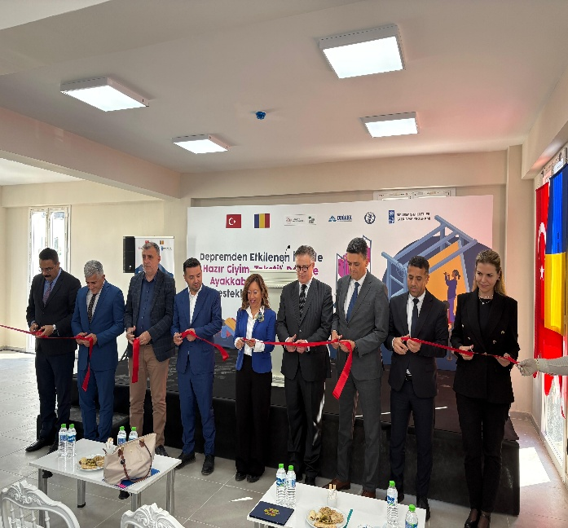 | 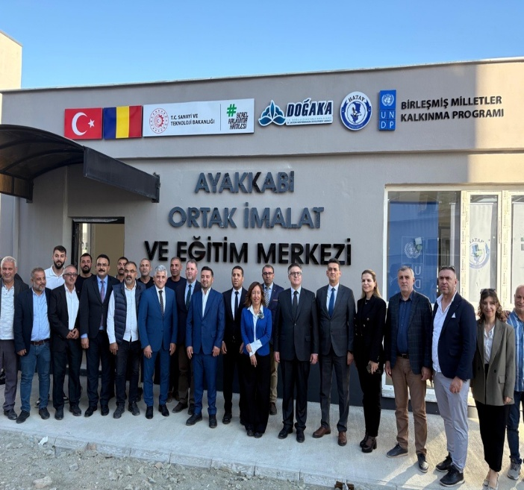

Activity 2: Establishment and equipment of one common-use laser cutting facility for small apparel businesses in Kahramanmaraş city center at a rental building:
A laser-cut fabric cutting facility has been established for the common use of garment manufacturers in Kahramanmaraş. Two laser cutting fabric cutting machines have been procured. The facility was established in September 2024.
Facility, officially inaugurated on 3 October 2024 during the Opening Ceremony of the Common-Use Automatic Fabric Cutting Facility for the Ready-Made Garment Sector in Kahramanmaraş, with the participation of the Embassy of Sweden. Additionally, it’s operated by the Kahramanmaraş Tailors and Garment Manufacturers Chamber, which also covers all operational expenses. The facility provides pre-sewing fabric cutting services, and since its official opening, approximately 70 enterprises have benefited from the facility, including both sole proprietorships and limited liability companies. Also the facility currently employs one staff member

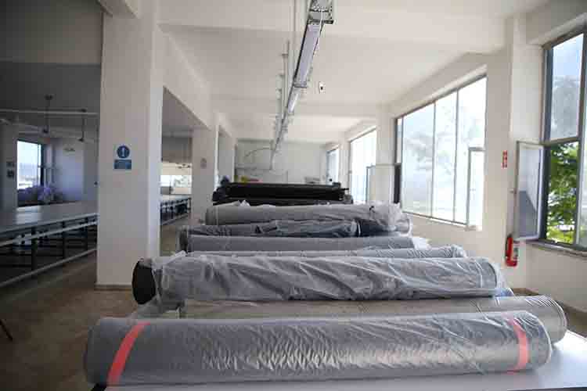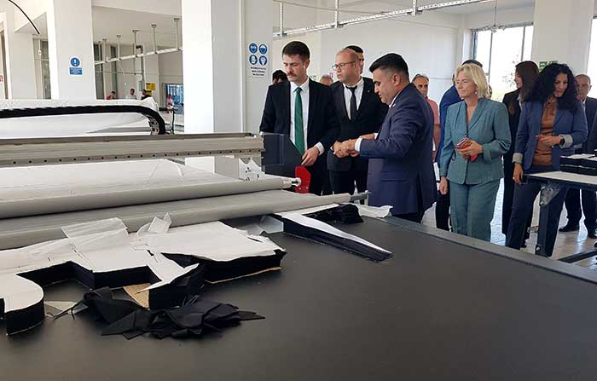

Output 2: Enhancing the business capacity of companies in the footwear and apparel sectors.
Within the scope of Output II, the project focused on strengthening the business and operational capacities of small and medium-sized enterprises (SMEs) in the footwear and apparel sectors affected by the earthquake. The aim was to support companies in resuming production, reconnecting with markets, and enhancing their competitiveness through tailored business development services.
Activity 1: Provision of business development support to businesses in footwear and apparel sectors for better integration to supply chains, increased exportation capacity, developing value chain, and branding.
A total of 13 consultancy programmes and 19 training programmes were implemented to enhance the business development, management, and technical capacities of enterprises operating in the footwear and apparel sectors in the earthquake-affected provinces. In addition, 115 enterprises (36 women led businesses) benefited directly from both training and consultancy support. These interventions helped strengthen local production capacity, improve business performance, and facilitate access to new market opportunities. As a direct outcome of these activities, 139 individuals were employed in the supported sectors, contributing to livelihood recovery and economic resilience in the region, in collaboration with IHKIB.
The training and consultancy programmes focused on the following topics:
Training Programs:
- Quality training
- Brand development training
- Training on Techniques for Finding Markets and Customers
- Ironing Techniques Training
- Sewing and Overlock Machine Operation Training
- Basic Patternmaking Training
Consultancy Programs:
- Business Competitiveness Enhancement Consultancy
- Export Development Consulting
- Social Compliance Management Consulting
- Lean Manufacturing Consulting

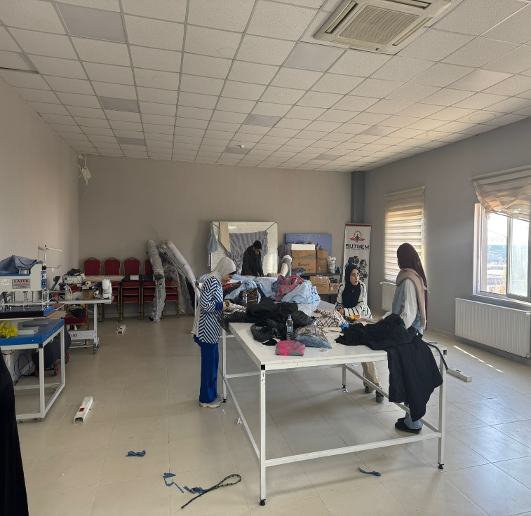 | 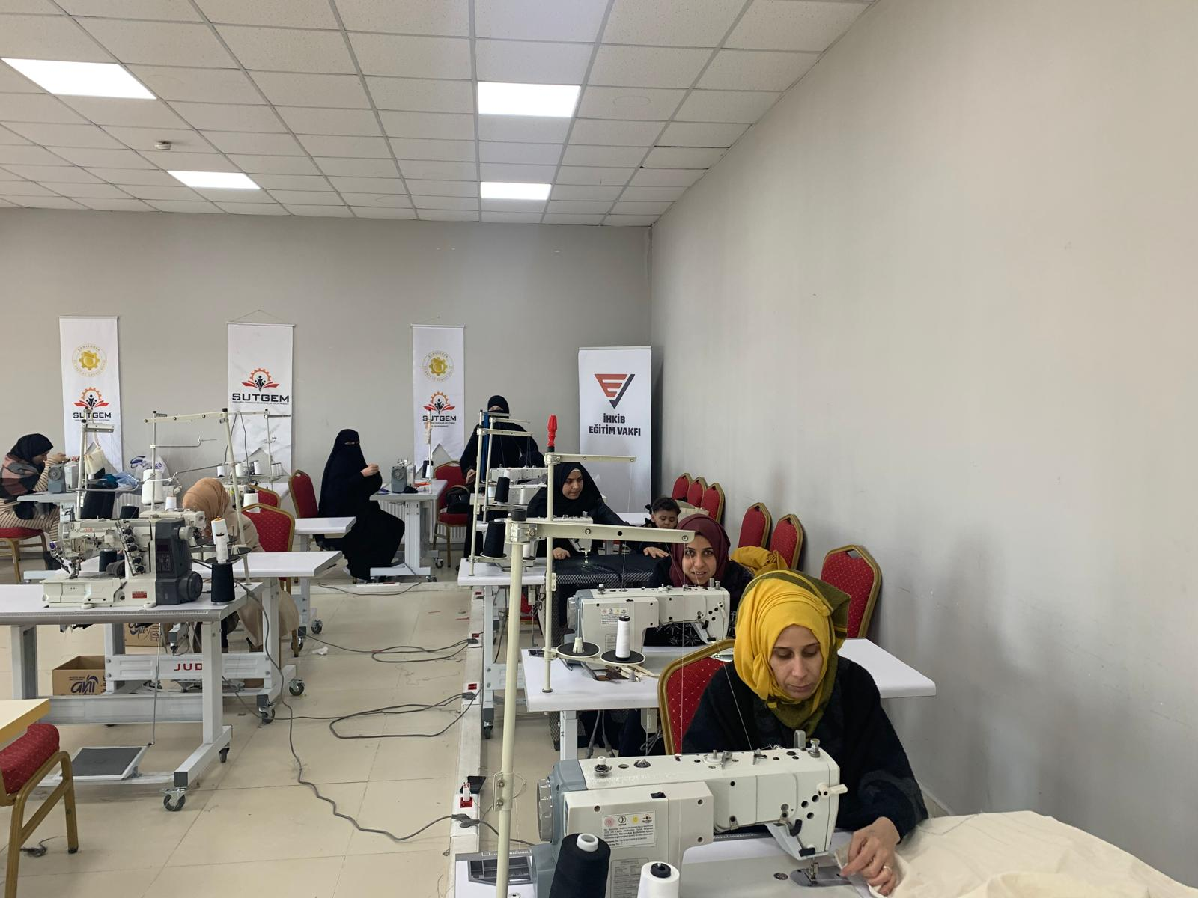

Activity 2: Provision of business-to-business matchmaking opportunities through events organized in the earthquake region.
In cooperation with the İstanbul Ready-Made Garment Exporters’ Association (İHKİB), three business-to-business (B2B) matchmaking events were organized alongside with the İFCO and TEXHIBITION fairs in Istanbul to promote commercial linkages between enterprises from the earthquake-affected region and potential buyers. A total of 34 enterprises from Hatay and Kahramanmaraş participated in these events, meeting with 154 domestic and international buyers representing leading brands and distributors. As a result of these engagements, 17 enterprises expanded their supply chains and/or export activities by adding at least one additional channel. These events created significant opportunities for local producers to reintroduce their products to the market, rebuild trade relations disrupted by the earthquakes, and explore new export channels. As a result, several enterprises established new business contacts and initiated negotiations for future supply agreements, contributing to the long-term recovery and reintegration of the regional industries into national and global value chains.
Success Story
Ozkonus Textile: Ozkonus Textile, reported that the project provided substantial support to the company’s institutional development and market readiness. As part of efforts to present a more corporate and professional profile, the company transitioned from a sole proprietorship to a limited liability company, thereby increasing its eligibility for public support schemes.
Significant efforts were also made to strengthen the company’s digital presence, including extensive work on the corporate website and investments in professional equipment to improve product photography. Through participation in trade fairs and B2B matchmaking events organized under the project, Ozkonus was able to identify operational gaps, enhance internal capacities, and expand its customer network.
While domestic market activities continue to grow, the company is now export-ready and plans to initiate overseas market research visits as the next step in its internationalization strategy.
Temberz Textile: They reported that it benefited significantly from the project, particularly through participation in trade fairs and B2B matchmaking activities, which enabled the company to expand its customer base and strengthen commercial linkages. As a direct outcome of these engagements, Temberz Tekstil began exporting to Tchibo Germany, marking a major milestone in the company’s international market access.
The company further indicated that export orders are expected to continue in the coming year, reflecting the sustainability of the partnerships established through the project.

Table 2: Summary of B2B and Trade Fair Events
Event Title | Date | Time | Venue | Number of Participation Companies | Total B2B Meetings | Origin of Participants
B2B Meeting Event | 7 February 2025 | 10:00 – 17:00 | Turkish Exporters Assembly (TİM), Foreign Trade Complex Conference Hall, Istanbul | 26 companies (9 participants and 17 business counterparts) | 153 one-to-one meetings | Hatay, Urfa, and Kahramanmaraş
IFCO Fair – Istanbul Expo Center | 20–22 August 2025 | 10:00 – 17:00 | Istanbul Expo Center, IFCO Fair | 41 companies (24 participants and 17 business counterparts) | 153 one-to-one meetings | Hatay, Urfa, and Kahramanmaraş
TEXHIBITION Fair – Istanbul Expo Center | 10–12 September 2025 | 10:00 – 17:00 | Istanbul Expo Center, TEXHIBITION Fair | 41 companies (24 participants and 17 business counterparts) | 153 one-to-one meetings | Hatay, Urfa, and Kahramanmaraş

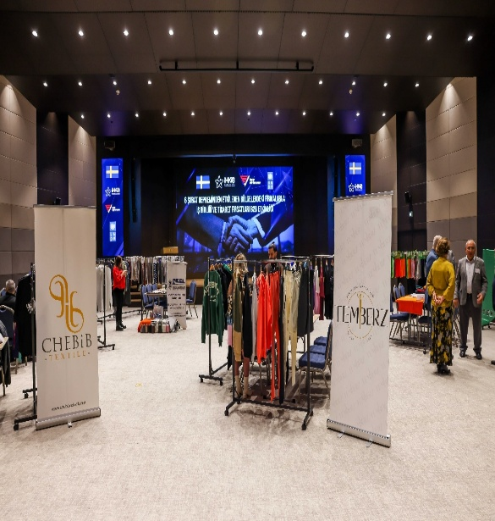 | 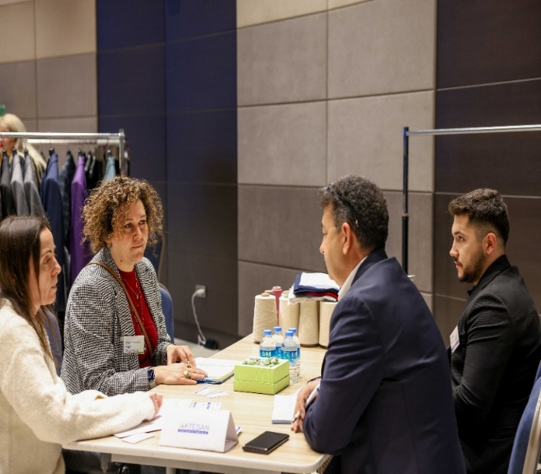
Output 3: Enhancing the employment capacity among earthquake victims through private sector-driven vocational and technical skills building and matchmaking prioritizing NEET youth and women.
Activity 1: Dissemination of private-sector-driven technical vocational training and training of trainers activities in cooperation with textile companies in Kahramanmaraş.
Within the scope of this activity, private-sector-led vocational training programmes were organized in Kahramanmaraş to strengthen the skills of workers and job seekers in the textile and apparel sectors. The trainings were developed in close cooperation with leading textile companies and the İHKİB Education Foundation, ensuring full alignment with actual market needs and employment opportunities.
Through these programmes, 995 individuals received training, including 968 NEET youth and 909 women
Activity 2: Job matchmaking services to job seekers and businesses in the footwear and ready-wear sectors.
By facilitating sustainable linkages between skilled workers, local producers, and broader national and international supply chains, the project improved production efficiency, strengthened market integration, and enhanced export readiness in the footwear and ready-to-wear sectors. Implemented in close collaboration with İHKİB, these targeted interventions supported capacity development at the enterprise level and enabled skilled individuals to access decent employment opportunities. As a result, 139 (46 women, 93 men) individuals were employed in the supported sectors, contributing to the restoration of livelihoods, the revitalization of local economies, and the strengthening of long-term economic resilience in the region.

Table 1: Number of individuals who are employed
 | SuTP |  | Turkish |  | Grand Total
Province | Man | Woman | Man | Woman
Kahramanmaraş | 11 | 4 | 81 | 41 | 137
Şanlıurfa |  | 1 | 1 |  | 2
Grand Total | 11 | 5 | 82 | 41 | 139

On 10 October 2025, the closing of the activities carried out in Şanlıurfa with IHKIB took place, with the participation of sector stakeholders, representatives from the private sector, the President of the Şanlıurfa Chamber of Commerce and Industry, the UNDP Türkiye Deputy Resident Representative, the Deputy Secretary General of IHKIB, and respresentatives from KİPAŞ, KIĞILI, LCW.
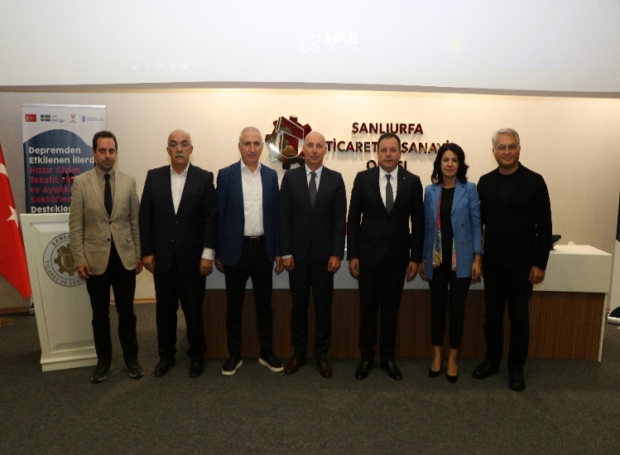 | 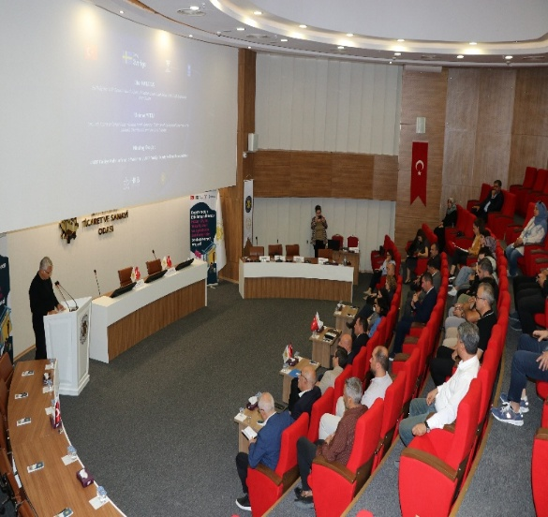
Output 4: Increasing the resilience of earthquake victims through mental health and psycho-social support services.
Activity 1: Provision of mental health and psycho-social support services.
Disaster and Trauma Mental Health Studies Association (TARDE), mental health and psycho-social support (MHPSS) services were provided to business owners, employees, and their families in the footwear and ready-wear sectors affected by the earthquakes in Hatay and Kahramanmaraş. TARDE operationalized the Occupational Mental Health Centers in both provinces, focusing on strengthening the psychological well-being and resilience of earthquake-affected workers and their communities.
Throughout 2024, a total of 574 individuals directly benefited from counselling and therapy services, while by 2025, this number had reached 1,149 people of whom 682 were men and 467 were women, all from Hatay and Kahramanmaraş provinces These interventions addressed key issues such as trauma, anxiety, family conflicts, and adaptation challenges caused by the earthquakes. Through continuous mental health support, TARDE contributed to improving emotional stability, workplace functionality, and overall community recovery within the affected industrial sectors.
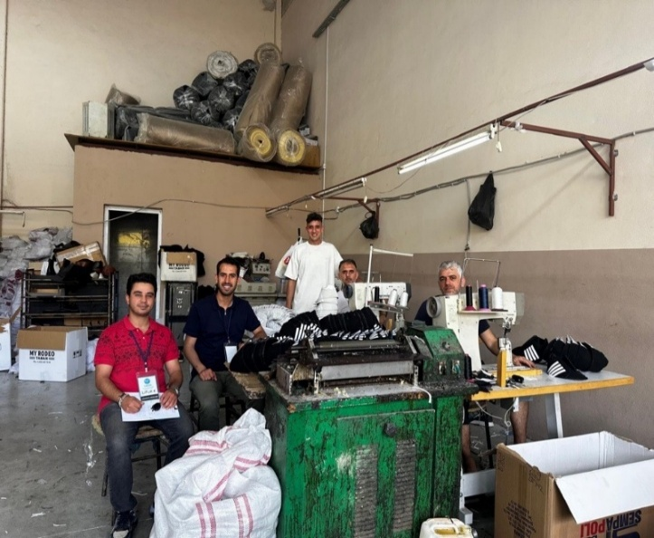 | 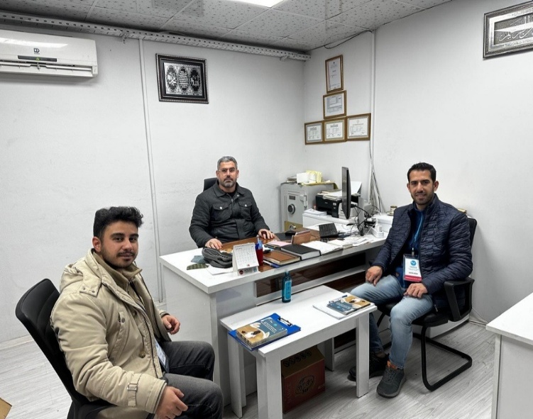
Activity 2: Increasing the awareness of the target population on mental health and resilience.
Complementing the direct support services, TARDE implemented awareness-raising activities aimed at promoting mental health literacy and resilience among the broader population in Hatay and Kahramanmaraş. Awareness campaigns were carried out through the distribution of information materials and brochures, community-based sessions, and outreach within industrial zones. By 2024, In total, over 11,000 individuals were reached through these awareness and information materials, encouraging open dialogue on mental health, reducing stigma, and fostering coping skills among earthquake-affected workers and their families. By integrating psychosocial well-being into the recovery framework, these efforts supported a more sustainable and inclusive approach to post-disaster rehabilitation in the region. In 2025, information materials were distributed through household visits and at the center, reaching approximately 2,001 individuals.
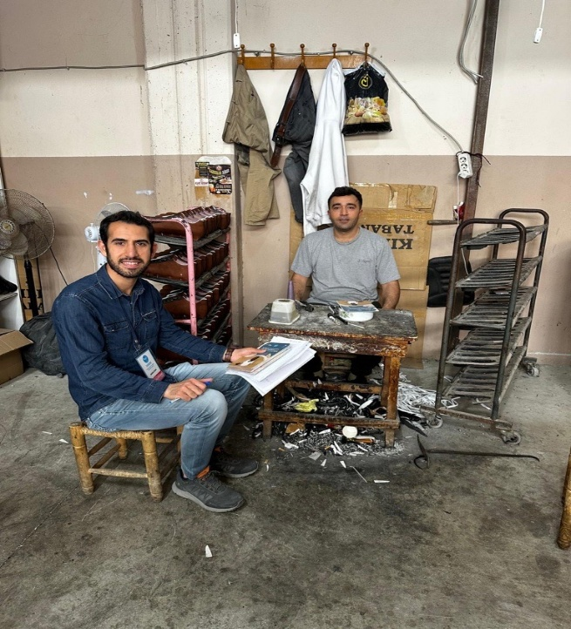 | 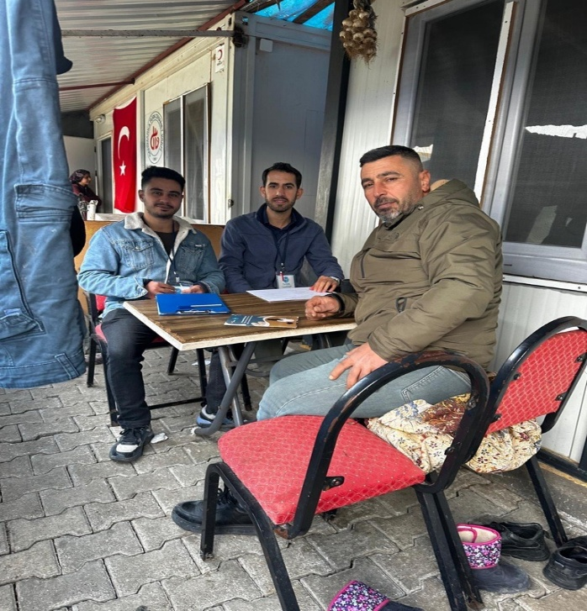
- Contribution to Gender Equality
The STRIDE project was designed under the GEN2 marker, ensuring that gender equality was systematically integrated into all stages of planning, implementation, and monitoring. A gender-responsive approach was applied across all activities, including vocational trainings, business development programmes, B2B events, and psychosocial support services. Particular emphasis was placed on increasing women’s participation in the textile, leather, and footwear sectors, where they traditionally face barriers to both entry and career progression. The project encouraged women-led SMEs to make use of the established common-use facilities and prioritised outreach to NEET women and young women seeking employment. All interventions were planned and reviewed in close consultation with the UNDP Gender Analyst, ensuring responsiveness to the specific needs and challenges of women in the earthquake-affected region.
Although the overall number of women employed (46) was lower than men, women still represented an important share of the workforce—especially in a sector where they are often underrepresented in formal and stable positions. The project ensured strong female engagement in psychosocial support services, with women accounting for 40.6% of participants, and reached thousands more through awareness campaigns. Women-led businesses were also included throughout the business development and B2B activities. Moving forward, the project’s integrated gender approach could be further strengthened through more targeted measures—such as dedicated support programmes or flexible training schedules—to enhance women’s participation in technical vocations and leadership roles across these sectors.
Table 3: Female Participation Among Employed Individuals Within the Project (IHKIB EV)
Province | Total Women | % of Total Women
Kahramanmaraş | 45 | 97.83%
Şanlıurfa | 1 | 2.17%
Grand Total | 46 | 100%
Number of Individuals Receiving Vocational and Skills Training (IHKIB EV)
Category | Number of Individuals
Total trained individuals | 995
NEET youth | 968
Women participants | 909
Gender Distribution of Beneficiaries Receiving Psychosocial Support (TARDE Activity)
Category | Total Beneficiaries (2025) | Women | Men | Percentage of Women (%)
Psychosocial Support Recipients | 1,149 | 467 | 682 | 40.6%

Indicator Based Performance Assessment

Description | Indicators | Baseline | Target  (End of project period) | Cumulative Realization  of the Year (2025) | Explanation if there is significant deviation from the target
The physical capacity of businesses in the leather/footwear and apparel sectors will be supported through the establishment of common-use facilities. | 1.1. Number of common production facilities established/rented and operational. | 0 | 2 | 2 | Production facility in Kahramanmaraş has been established in 2024. Antakya has been established in and became operational end of October 2025.
 | 1.2. Number of production facility equipped for common use. | 0 | 2 | 2 | Production facility in Kahramanmaraş has been equipped in 2024. Antakya has been equipped in October 2025.
Enhancing the business capacity of companies  in the footwear and apparel sectors. | 2.1.1 Sex-disaggregated number of small businesses that received business development support | 0 | 100  (at least 20 women led businesses) | 115 (36 women led business)
 | 2.1.2 Number of businesses that increased their supply chains/exportation at least by 1 additional channel. | 0 | 10 | 17 | Businesses attended and established partnerships in B2B meetings with dealers.
 | 2.2.1 Number of capacity building/ matchmaking events organized. | 0 | 2 | 3 | 2 more B2B events have been organised in August and September 2025  İstanbul
Enhancing the employment capacity among  earthquake victims through private sector driven  vocational and technical skills building and  matchmaking prioritizing NEET youth and women. | 3.1.1 Number of a) total individuals, b) women, c) NEET individuals who received on the job technical vocational training in ready- wear sector disaggregated by sex and NEET status. | 0 | a) 1000  b) 400  c) 200 | a)995  b)909  c) 968 | Kahramanmaraş, Şanlıurfa
 | 3.2.1 Number of individuals placed in sustainable jobs following 6 months on the job technical vocational training. | 0 | 300 | 139 | 46 Female, 16 SuTP  After the earthquake disasters, construction sector has been developed and become more open for young employment by offering high rate of income compared to textile sector. Therefore, potential workforce in the earthquake region shifted to construction sector. Project target has not been achieved .
 | 3.2.2 Number of businesses that participated in apparel sectors matchmaking program and create employment in the earthquake zone. | 0 | 10 | 8 | After the earthquake disasters, construction sector has been developed and become more open for young employment by offering high rate of income compared to textile sector. Therefore, potential workforce in the earthquake region shifted to construction sector. Project target has not been achieved Kahramanmaraş, Şanlıurfa
Increasing the resilience of earthquake victims  through mental health and psycho-social support  services. | 4.1.1. An Occupational Mental Health Center operationalized in Hatay. | No | Yes | Yes | Mental Health Center has been established and oprational since July 2024 and were on sercive until september
 | 4.1.2. Sex-disaggregated number of individuals who received mental health and psycho-social support services. | 0 | 1000 | 1149 | 682 male, 467 female
 | 4.2.1. Sex-disaggregated number of community members reached in earthquake zone through awareness raising activities. | 0 | 5000 | 13427 | Beneficiaries reached through brochures, social media tools and community events. So gender disaggregation cannot be reported

- Project Risks and Issues

Updated project risks and actions
Project Risk 1: The ongoing physical and psychological effects of the earthquake, creating difficulties for both businesses and individuals
Actions Taken: TARDE were integrated into the project to strengthen resilience and motivation among business owners and workers.
Outcome: Resolved. TARDE operationalized Occupational Mental Health Centers in Hatay and Kahramanmaraş, providing psychosocial counselling to 1,149 individuals and reaching 11,000+ people through awareness campaigns.
Project Risk 2: Limited availability of skilled labor. post-earthquake migration and job losses have reduced the local skilled workforce.
Actions taken: Vocational and technical training programs were organized for 894 individuals, focusing on the needs of the textile and footwear sectors. Job-matching activities linked trained individuals with local businesses.
Outcome: Through the provision of training and consultancy services, 114 business improved their business capacity, and 139 individuals were employed, supporting the recovery of the local labor market and production continuity.
Project Risk 3: High inflation and rising production costs affected the financial stability of SMEs in the apparel and footwear sectors.
Actions taken: Business consultancy programs included financial management components. İHKİB supported SMEs through B2B matchmaking and export promotion, enabling them to access new buyers and stabilize their income.
Outcome: SMEs enhanced their financial planning skills and gained new commercial linkages. 34 enterprises participated in B2B events, meeting 154 buyers, which helped expand their market access and income potential.
Project Risk 4: Delays in the procurement and installation of machinery and equipment, caused by supply chain disruptions and fluctuating market conditions.
Actions Taken: Early supplier engagement was initiated, and alternative vendors ere identified to prevent interruptions in the procurement timeline. Technical specifications and tender documents were finalized in close coordination with local industry experts to accelerate the process.
Outcome: Procurement processes were completed within the revised schedule, enabling the timely establishment of common-use facilities. This ensured that SMEs gained access to modern production technologies without significant delays, supporting uninterrupted project implementation.

Updated project issues and actions

Project Issue 1: Following the earthquake, population displacement and economic disruption in the target provinces posed challenges in reaching the planned number of beneficiaries for vocational training and capacity development activities under STRIDE.
Actions Taken: To mitigate this challenge and maintain the planned implementation timeline, flexible delivery mechanisms were adopted. In addition to in-person trainings, alternative outreach methods and coordinated beneficiary mobilization efforts were implemented in collaboration with local stakeholders and sector representatives.
Outcome: Resolved. Vocational and sectoral capacity development trainings successfully reached the initially planned participation targets, contributing to enhanced workforce skills and strengthened resilience within the regional textile ecosystem
Project Issue 2: In provinces such as Hatay or Kahramanmaraş, where the earthquake impact was more severe, many individuals were living in temporary shelters or had experienced recent losses. In this context, providing direct psychosocial intervention without prior needs assessment and beneficiary readiness could have created protection and ethical risks for vulnerable groups.
Actions Taken: To mitigate this risk, psychosocial support activities were designed using a gradual and needs-sensitive approach. The interventions were implemented in collaboration with TARDE, ensuring that counselling services, group sessions, and awareness-raising activities were delivered in a safe and appropriate manner.
Outcome: Resolved. The risk of unintended psychological harm was minimized, and psychosocial support services were successfully integrated into the recovery-oriented project framework, contributing to community well-being and resilience.

- Monitoring Arrangements

During the implementation period, regular meetings were held with the participation of the project manager and representatives of the project partners (DOGAKA, IHKİB Education Foundation, TARDE). The progress of ongoing activities, risk management issues and solutions were discussed and solutions were developed through these regular coordination meetings with the responsible parties.
In addition to the follow-up conducted by the Hatay-based Project Assistant, the Project Manager carried out several monitoring visits to project provinces to oversee implementation and ensure the quality of activities in the field.
As a post-earthquake recovery initiative, the project primarily targeted the most affected beneficiary groups in the region. In line with the evolving needs of the post-crisis environment, activities were adjusted, and emergency measures were introduced to ensure relevance and impact.
Progress and achievements were regularly monitored and documented by the M&E Officer. Collected data and information were systematically shared with internal and external stakeholders, ensuring transparency and accountability throughout implementation. There has been a monitoring visit conducted by the M&E Officer on 22 April 2025 to Hatay involving Mental Health Center and Common-Use Facility. Observations, lessons learned and recommendations have been shared with the project team via output verification report.

- Lesson Learned

Integrated Approach to Economic and Social Recovery
The STRIDE project showed that rebuilding the industrial sectors (footwear, textile, leather, ready-made garment) after a disaster requires a comprehensive approach that combines infrastructure repair, business support, skills training, and mental health assistance.
Including psychosocial support in the recovery process helped workers stay motivated, productive, and emotionally stable.
This experience proved that economic recovery and mental well-being go hand in hand, and both are necessary to build strong and resilient communities.
Significance of Common-Use Facilities for SME Resilience
The establishment of shared production facilities in Hatay and Kahramanmaraş proved to be an efficient and sustainable model for supporting small and medium-sized enterprises (SMEs) affected by the earthquake. Access to advanced equipment and collective production spaces helped reduce operational costs and enabled small producers to maintain their positions within supply chains. This experience underlines the importance of expanding such common-use models to other disaster-affected regions to enhance competitiveness and local production capacity. To improve long-term outcomes, it is recommended to establish coordination with local cooperatives, expand outreach to other sectoral actors at near provinces and design mobile service models to reach dispersed producers.
Empowering Women for Sustainable and Inclusive Recovery
Ensuring women’s participation in all project activities (from training to business development) contributed to more inclusive economic recovery. Targeting women-led SMEs and NEET women helped strengthen household resilience and local production. Future programmes should integrate gender-inclusive practices as a key element in local recovery efforts.
- Conclusions and Way Forward
The STRIDE project has successfully contributed to the recovery of the textile, leather, and footwear sectors in Hatay and Kahramanmaraş, the two provinces most severely affected by the February 2023 earthquakes. Through the establishment of common-use production facilities, the provision of business development and vocational training programs, and the integration of mental health and psychosocial support services, the project has provided comprehensive support to individuals and small businesses working to rebuild their Livelihoods.
STRIDE enabled small and medium-sized enterprises (SMEs) to regain their competitiveness and continue their activities by facilitating access to modern equipment and promoting collaborative production models. The project also helped create new employment opportunities, particularly for women and young people, and strengthened the overall resilience of the local economy.
The integration of gender equality and mental health issues into economic recovery proved highly effective and demonstrated that economic and social recovery mutually strengthen each other. The project's implementation also highlighted the critical importance of local partnerships, particularly with DOĞAKA, the İHKİB Education Foundation, and local chambers of industry, to ensure ownership and sustainability. Through the partnership with TARDE, it was observed that mental health centers played a critical role in supporting the psychosocial recovery of earthquake-affected populations and improving overall wellbeing within impacted communities. At the same time, this experience highlighted concerns related to the long-term sustainability of these services and the gender balance among counselling staff. Based on the lessons learned with TARDE, future interventions should integrate psychosocial support mechanisms into local health or municipal systems and ensure gender-sensitive staffing structures to enhance inclusivity and comfort for beneficiaries.

Moving forward, it is crucial to scale up and replicate the STRIDE model in other earthquake-affected provinces and to leverage lessons learned to improve design and access.
The project has two donors. Details of budget utilization is provided separately for the funds of the Government of Sweden and Government of Romania.

- Financal Status
The project has two donors. Details of budget utilization is provided separately for the funds of the Government of Sweden and Government of Romania.

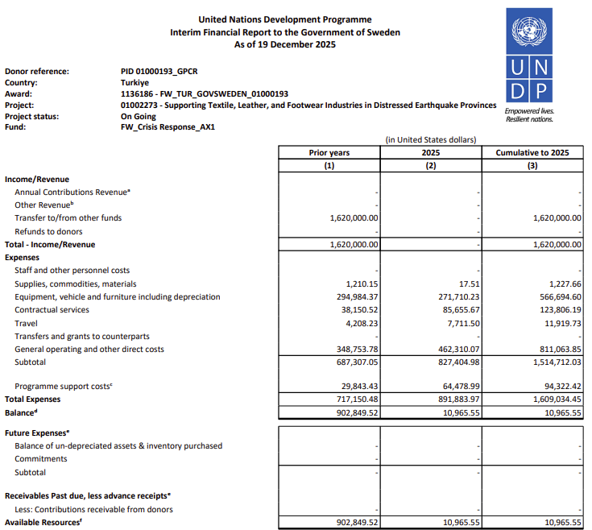

- Annexes

Annex1: DOĞAKA (ACT1)
Annex2: İHKİB (ACT2_3)
Annex3: TARDE (ACT4)

